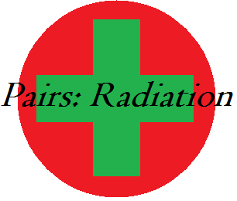

## Contents

* Installation
* Starting the Game
* Playing
* Cards
  + Shield cards
  + Radiation cards (easy)
  + Radiation cards (Hard)
* Matches
* Levels

## 

## Installation

1. To start the installation process of Pairs: Radiation, navigate to the CD which contains the game, then click on the “PairsRadiation Setup.msi”.

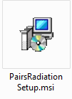

1. When this screen appears, click next to continue.

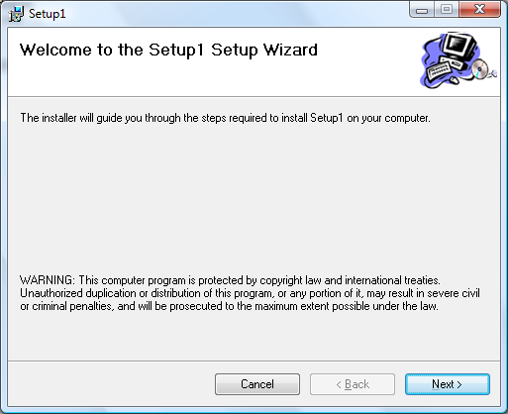

1. Choose the location where you would to install to, and what user groups it is installed for, then click next to continue.

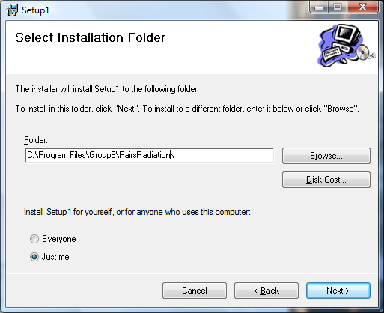

1. Confirm the installation and click next to continue

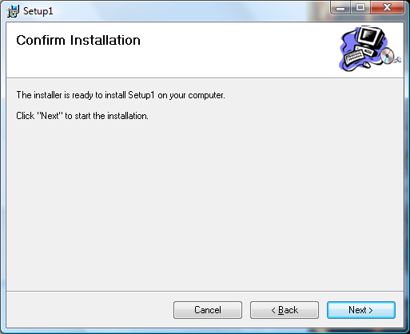

1. Wait while the installation completes.

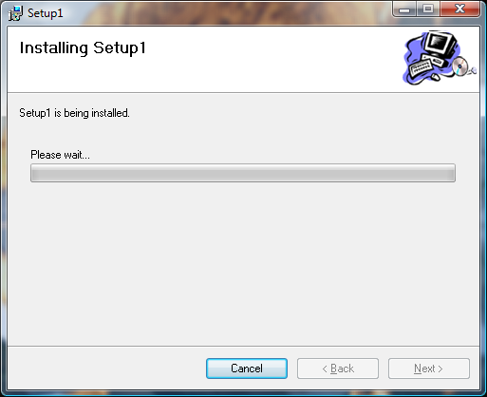

1. When setup is complete press close and you are ready to play.

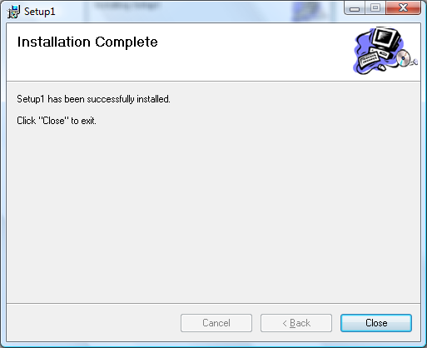

## Starting the game

To start the game double click the Pairs: Radiation icon (*figure 1*)

*figure 1*

Pairs:

Radiation.exe

When the game starts you will be presented with the screen below:

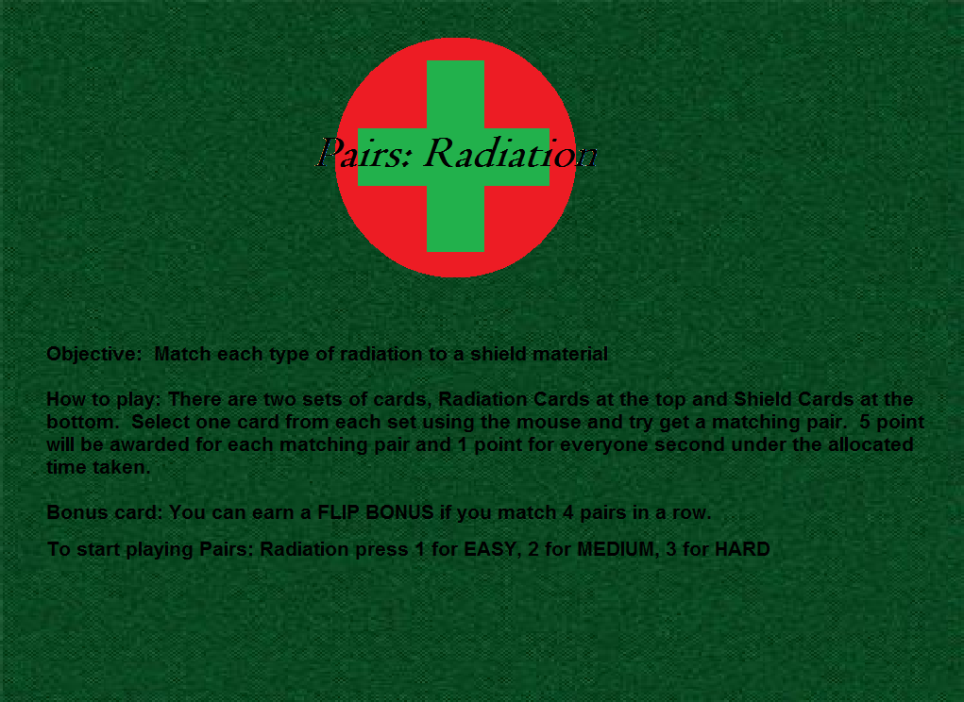

*figure 2*

After reading how to play, choose the difficulty level you wish to play, (Easy, Medium or Hard). Press “1” for Easy, “2” for Medium, “3” for Hard. Then the game will immediately start on your chosen level, you can return at to this screen at anytime to start a different level although your current score will be lost unless you complete that level. After the game has ended you will be returned to this screen to choose another level if you wish to play again.

Easy level (*figure3*).

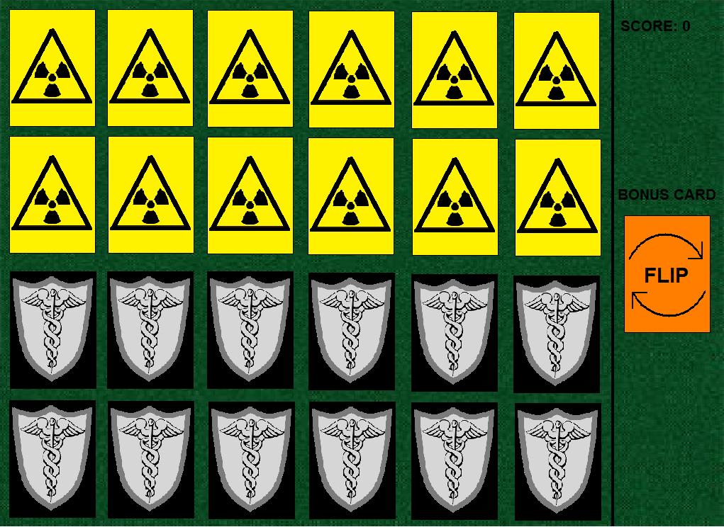

*figure 3*

## Playing

To play select one radioactive card and one shield card. Select a card from each set by using the mouse to click on the card it will then flip over. *Figure 4* seen below is an example of an incorrect match, when an incorrect match it made the selected cards will flip back over and you can make another selection of a card from each set.

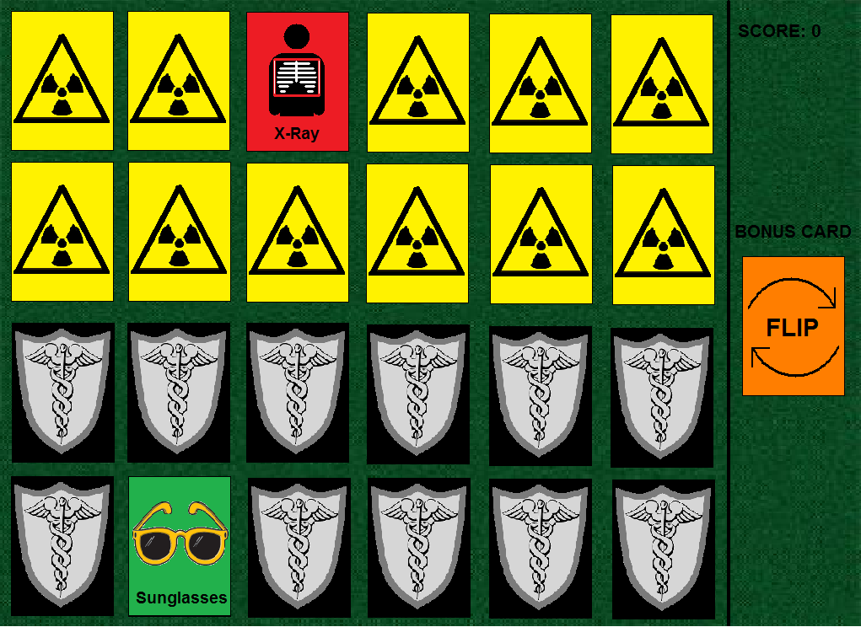

*figure 4*

When a correct selection is made both cards will stay flipped over and you will earn points. See *figure 5*.

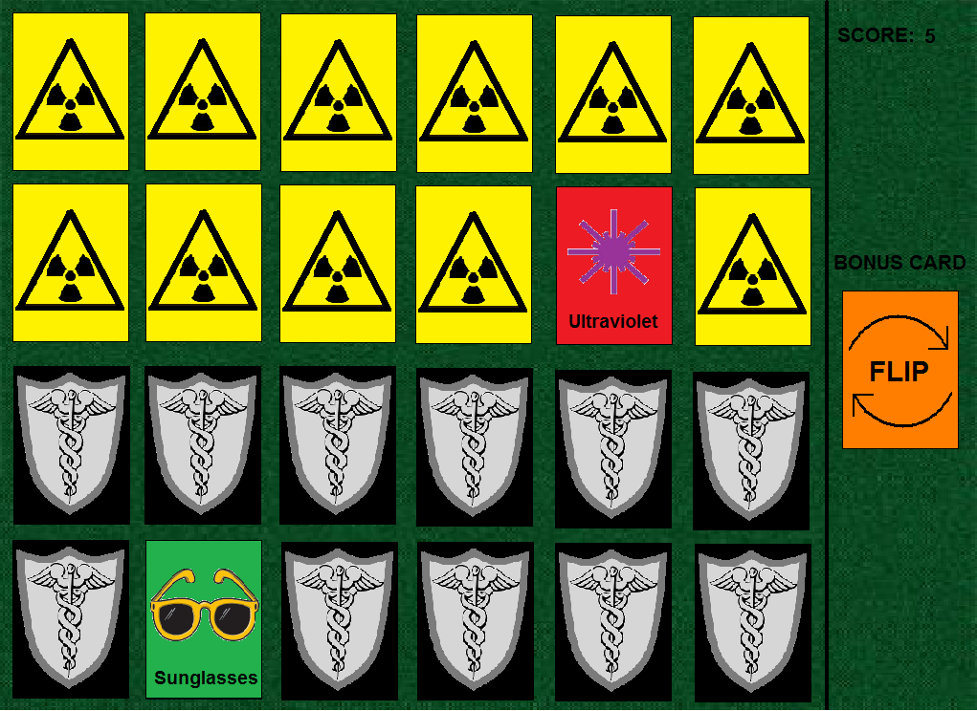

*figure 5*

## Cards

## Shield Cards

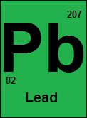 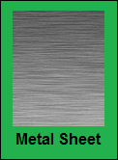 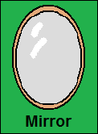

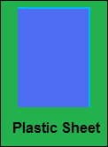 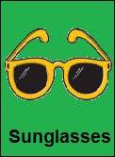 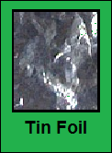

## Radiation Cards (Easy)

 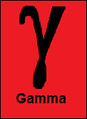 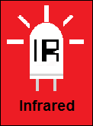

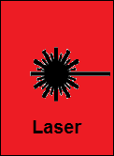 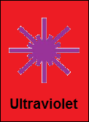 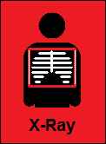

## Radiation Cards Hard

 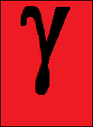 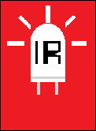

  

## Matches

|  |  |  |  |
| --- | --- | --- | --- |
| **Easy Card** | **Hard Card** | **Shield Card** | **Description** |
| Beta.bmp | Beta hard.bmp | plastic sheet.bmp | Beta particles are a low penetrating high speed electron and can be stopped by a couple of centimetres of low density material such as a Plastic Sheet. |
| Gamma.bmp | Gamma hard.bmp | Metal sheet.bmp | Gamma rays are a high penetrating form of radiation which requires a higher density material such as a Metal Sheet to stop them. |
| Infrared.bmp | Infrared hard.bmp | Tin Foil.bmp | Infrared radiation is a type of electromagnetic radiation which has a wavelength longer than that of visible light. It can be deflected by any shiny material such as a small piece of Tin Foil |
| Laser.bmp | Laser hard.bmp | Mirror.bmp | Laser beams are a low divergence beam of visible light; they can be deflected by any shiny material such as a Mirror. |
| ultraviolet.bmp | ultraviolet hard.bmp | Sunglasses.bmp | Ultraviolet light is an electromagnetic emission with a shorter wavelength than that of visible light; it can be blocked by Sunglasses to protect the eyes. |
| X-Ray.bmp | X-Ray Hard.bmp | Lead.bmp | X-rays are a form of electromagnetic radiation and require a very high density material to stop it, such as Lead. |

## Levels

### EASY

In Easy mode there will be 12 pairs of cards to match, the radiation cards will have descriptions under the symbol. Score rate will be normal. Time limit is 90 seconds.

## MEDIUM

In Medium mode there will be 18 pairs of cards to match, the radiation cards will have descriptions under the symbol. Score rate will be double. Time limit is 90 seconds.

## HARD

In Hard mode there will be 24 pairs of cards to match, the radiation cards will **NOT** have descriptions under the symbol. Score rate will be triple. Time limit is 90 seconds.

## Powerup Card

The powerup card seen below (*figure 6*) can be obtained by matching 4 corrects pairs of cards in a row. Once it is obtained it will appear in the side bar under the score. It can be used at anytime. When used it will flip all of the cards over for 1 second.

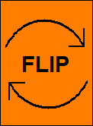

*Figure 6*